**If else Switch case Ternary Assignment**

1. **Using ternary operator compare 3 numbers and display the smallest number**

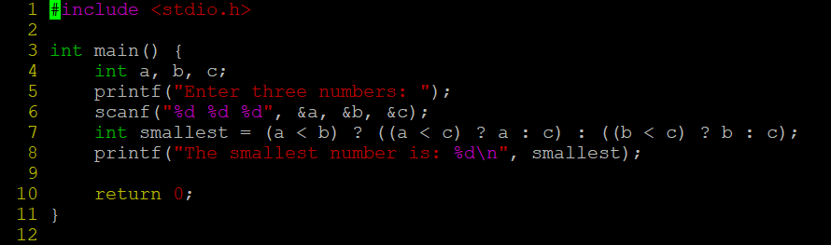

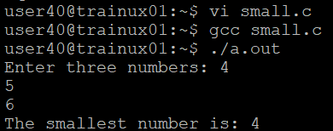

**2. WAP to read a designation code and display his designation as a string. Use the following mapping.**

**2 – Software Developer**

**3 – Senior Software Developer**

**4 – Team Lead**

**5 – Senior Team Lead**

**anyother value – incorrect designation code**

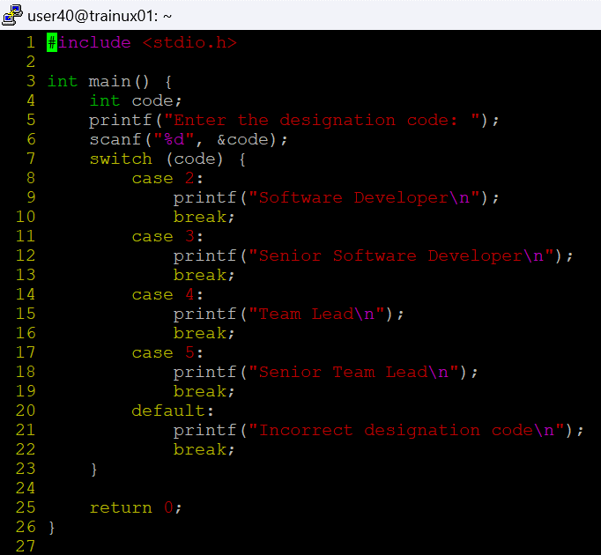

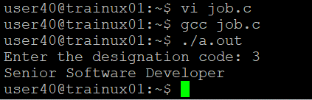

**3. WAP to test the eligibility for deployment post training. Need to fulfill all the 4 conditions. Read the score inputs from user at runtime. (Use if else and switch together).**

**i. Test1 Score >= 75%**

**ii. Test2 Score >= 75%**

**iii. Test3 Score >= 70%**

**iv. Project Score >=75%**

